*Simulation Task 2*

Report

*Group Names:*

*1. Ahmad Magdy Muhammad Sec (1)*

*2. Ahmad AbdEl-Latif Mhana Sec (1)*

*3. Ahmad Alaa AbdEl-Wahab Sec(1)*

*Problem Formulation*

*The Newspaper sells man can’t decide how many paper he should buy, so that he will get the highest profit.*

*Objective*

*We want to decide the number of papers to buy to achieve the highest profit overall the day for this Newspaper sells man.*

*Model Conceptualization*

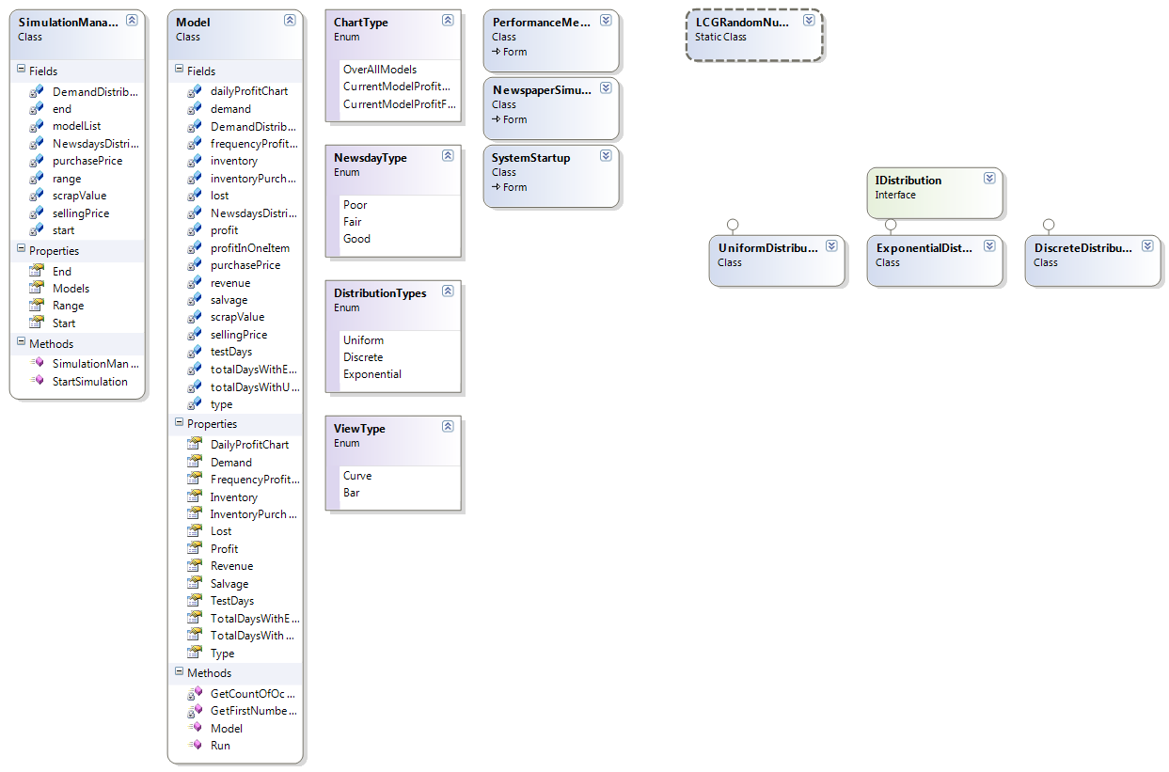

*Experimental Design*

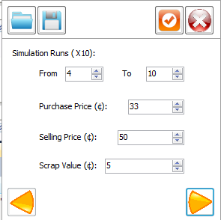

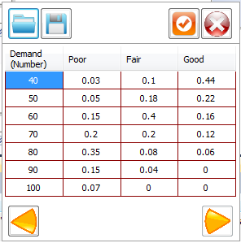

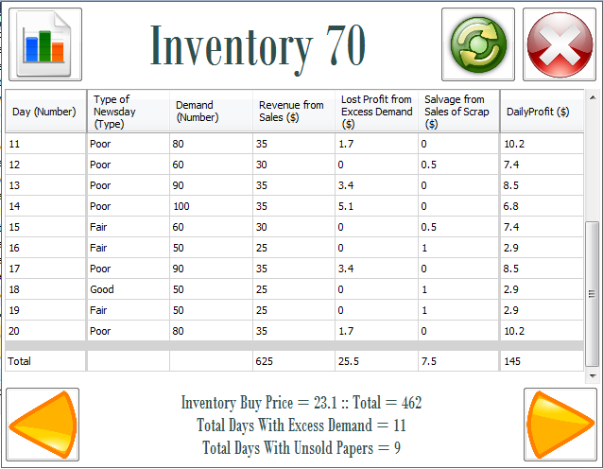

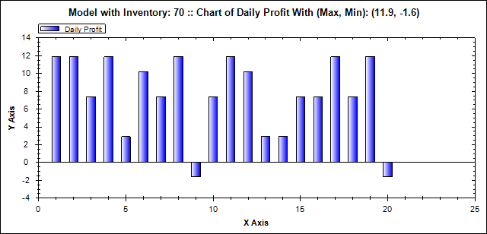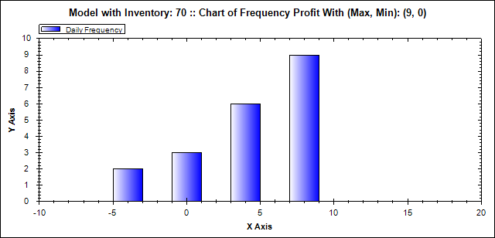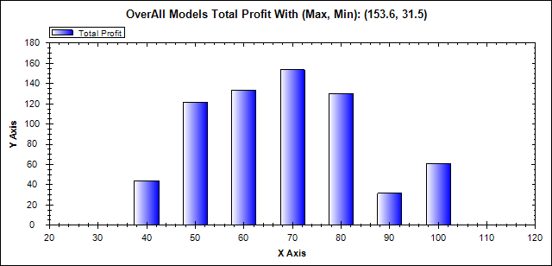

*Result Analysis & Conclusion*

*As I ran the simulation with values from 40 to 100,*

*The Max profit was around 70 newspapers bought overall the test values, so I am going to take 70 as the conclusion results.*

|  |  |
| --- | --- |
| *Total Revenue* | *625* |
| *Total Cost* | *462* |
| *Total Lost Profit from excess demand* | *25.5* |
| *Total Salvage from selling with scrap price* | *7.5* |
| *Net Profit* | *145* |
| *Number of Days having Excess Demand* | *11* |
| *Number of Days Having Unsold Papers* | *9* |